Kyle Romm

Eclipse Tutorial

Step 1: Download and Install JDK [Here](http://www.oracle.com/technetwork/java/javase/downloads/index.html)

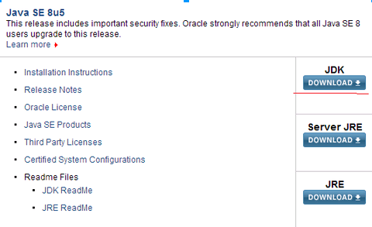

Step 2: Download Eclipse [Here](http://www.eclipse.org/downloads/)

Click dropdown and select your operating system and then download.

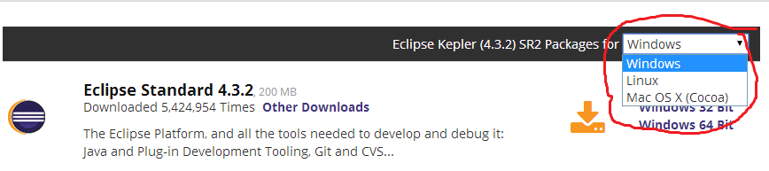

Step 3: After Eclipse has been downloaded, locate where it is in your computer. Right click the zip file and extract.

(To extract files, you can use programs such as 7zip or Winrar which can be downloaded [Here](http://www.7-zip.org/download.html) and [Here](http://www.win-rar.com/download.html?&L=0))

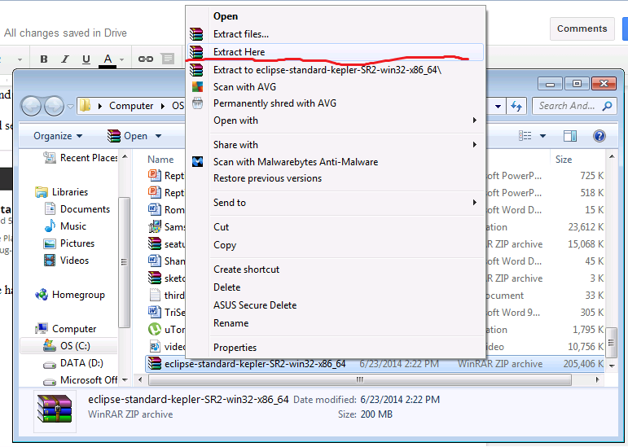

Step 4: Once Eclipse has been downloaded, extracted, and located on your computer, navigate to the eclipse folder. Once inside the eclipse folder, open the eclipse icon and begin. 